**Advanced Database Systems Practical-3**

1. Write a query that gets all the people with an age less than 20?

A: db.s4475157.find({“age”: {$lt:20}})

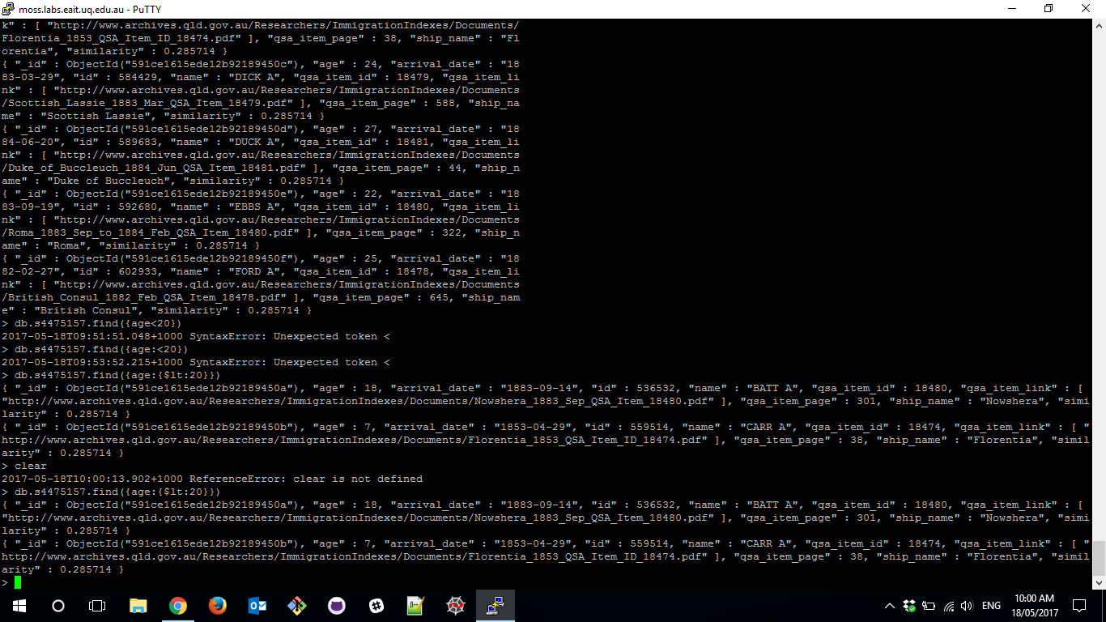

1. Update the user with the id field of 592680 to have a qsa_item_page of 222?

A:db.s4475157.update({“id”:592680},{$set:{“qsa_item_page”:222},$currentDate:{lastModified:true}})

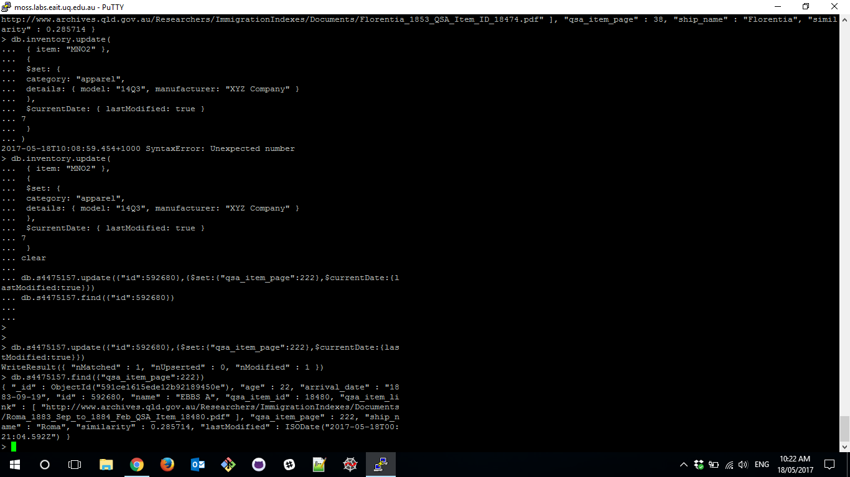

1. Write a query that prints out ONLY the names and the _id values of each person and order them alphabetically with respect to name?

A: db.s4475157.find({},{“name”:1}).sort({“name”:1})

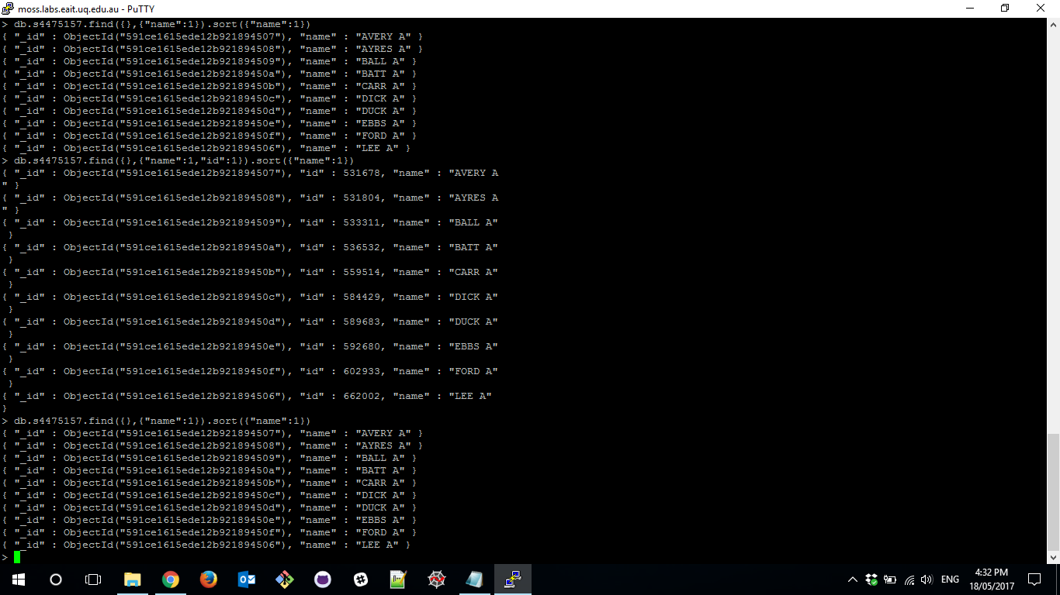

1. Create an index on the age field and rerun the query in Question 1 using the explain function to get the execution plan. Assuming that MongoDB created tree based index for the query, explain step by step the execution plan that was produced?

A: For creating index->db.s4475157.ensureIndex({“age”:1})

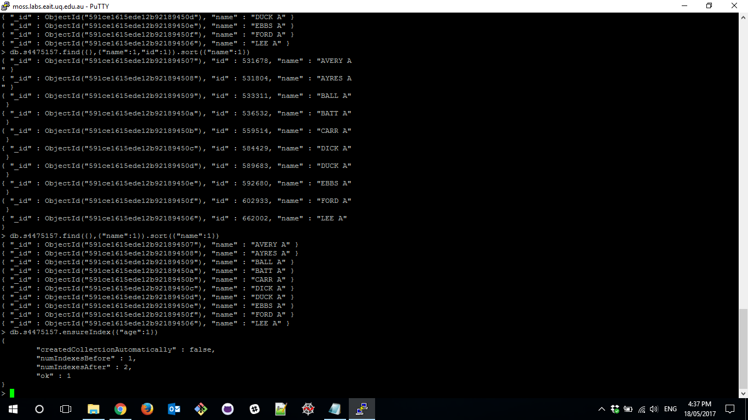

For re running Question 1 with explain function is:

db.s4475157.find({“age”:{$lt:20}}).explain()

